ALUMINUM ELECTROLYTIC CAPACITORS M.D.L.

TE Series
AXIAL Type 85℃

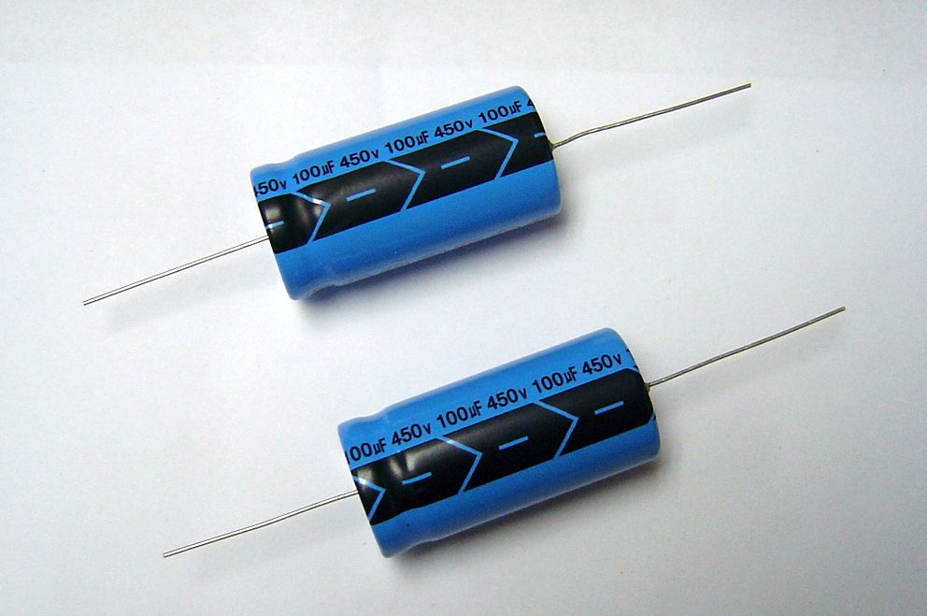

█ FEATURES
.85℃,2,000 hours assured
. Voltage range of 6.3 ~ 450V
.Wide operating temperature range,from -40℃~ +85℃
█ SPECIFICATION
Item | Characteristic
Operation Temp 使用溫度範圍 | -40℃ ~ +85℃
Capacitance Tolerance 容量範圍 | ±10%(K), ±20%(M) (at 20℃,120Hz)
Rated Voltage 額定電壓 | 6.3 ~ 100VDC | 160 ~ 450VDC
(20℃)  Leakage Current 洩漏電流 | I≦0.02CV or 3 (u A)Whichever is greater 選其最大值  (after 2 minutes applying the rated DC working Voltage at 20 ℃)(在20℃施加直流額定電壓2分鐘以後) | I≦0.03CV+15 (u A) for CV≦1000,  I≦0.02CV+25 (u A) for CV>1000  (after 5 minutes applying the rated DC working Voltage at 20 ℃)(在20℃施加直流額定電壓5分鐘以後)
(20℃)  Leakage Current 洩漏電流 | Where: I=Leakage Current (u A) , C=rated Capacitance (μ F) , V= working Voltage (V)
(at 20℃,120Hz)  Dissipation Factor (tan δ)  損失角 | Add 0.02 per 1000μ F for more than 1000μ F  (當靜電容量超過1000μ F時，容量每增加1000μ F，損失角正切值就增加0.02)
  W.V | 6.3 | 10 | 16 | 25 | 35 | 50 | 63 | 100 | 160 | 200 | 250 | 350 | 400 | 450
  tan δ | 23 | 20 | 0.17 | 0.15 | 0.12 | 0.10 | 0.09 | 0.08 | 0.15 | 0.15 | 0.20 | 0.20 | 0.24 | 0.24
(20℃)  Surge Voltage  突破電壓
  W.V | 6.3 | 10 | 16 | 25 | 35 | 50 | 63 | 100 | 160 | 200 | 250 | 350 | 400 | 450
  S.V | 8 | 13 | 20 | 32 | 44 | 63 | 79 | 125 | 200 | 250 | 300 | 400 | 450 | 500
Low Temperature Stability  低溫溫度特性 | Impedance ratio at 120 HZ 阻抗測試頻率為120Hz
  Rated Voltage (V) |  | 6.3 | 10 | 16 | 25 | 35 | 50 | 63 | 100 | 160 | 200 | 250 | 350 | 400 | 450
  Z(-25℃)  /+20℃ | ∮D<16 | 6 | 4 | 3 | 3 | 2 | 2 | 2 | 2 | 3 | 6 | 8 | 12 | 14 | 16
  Z(-25℃)  /+20℃ | ∮D≥16 | 8 | 6 | 4 | 4 | 3 | 3 | 3 | 3
  Z(-40℃)  /+20℃ | ∮D<16 | 10 | 8 | 6 | 6 | 4 | 3 | 3 | 3 | 4 | 8 | 10 | - | - | -
  Z(-40℃)  /+20℃ | ∮D≥16 | 18 | 16 | 12 | 10 | 8 | 8 | 6 | 6
Load Life Test  高溫負荷壽命 | After 2,000 hours application of rated voltage at 85℃,capacitors meet the characteristics requirements listed as below .在額定電壓85℃條件下，經過2,000小時後，電容特性要求如下表：
  Capacitance Change | Within ±20% of initial value
  Dissipation Factor | Less than200% of specified value
  Leakage Current | Within specified value
Shelf Life Test  無負荷壽命 | After leaving capacitors under no load at 85℃ for 1,000 hours and applying Voltage they meet the specified value for load life characteristics listed above .將電容器置於溫度為85℃、無電壓負荷狀況下，經過1,000小時後，再加電壓於電容器，其所測值標準應與有負荷時測試值相同。
Frequency Coefficient of Allowable Ripple Current  允許紋波電流的頻率係數
  Freq.(Hz)  Cap.( μ F) | 60 | 120 | 500 | 1K | 10K up
  Under 100 | 0.70 | 1.00 | 1.30 | 1.40 | 1.50
  100 to 1000 | 0.75 | 1.00 | 1.20 | 1.30 | 1.35
  1000 up above | 0.80 | 1.00 | 1.10 | 1.12 | 1.15
Allowable Ripple Current Vs;  Ambient Temperature  環境溫度對比允許紋波電流的比值
  Temperature(℃) | Under 50 | 70 | 85
  Multiplier | 1.78 | 1.40 | 1.00

ALUMINUM ELECTROLYTIC CAPACITORS M.D.L.

TE Series
AXIAL Type 85℃

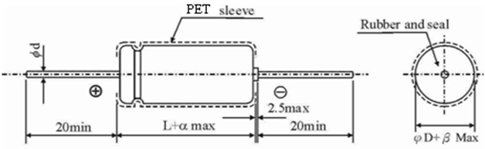
█ CASE SIZE & Max RIPPLE CURRENT
Dimension Diameter (∮D)×Length(L) mm Ripple Current: m A/rms at 85℃,120Hz
尺寸：直徑(∮D) × 長度L (mm) 紋波電流(m A) : 溫度85℃,測試頻率120Hz
WV  μ F | 6.3V |  | 10V |  | 16V |  | 25V |  | 35V |  | 50V |  | 63V |  | 100V
WV  μ F | SIZE | R.C | SIZE | R.C | SIZE | R.C | SIZE | R.C | SIZE | R.C | SIZE | R.C | SIZE | R.C | SIZE | R.C
0.10 |  |  |  |  |  |  |  |  |  |  | 5×12 | 1.5 | 5×12 | 3 | 5×12 | 3
0.22 |  |  |  |  |  |  |  |  |  |  | 5×12 | 3.5 | 5×12 | 4.5 | 5×12 | 5
0.33 |  |  |  |  |  |  |  |  |  |  | 5×12 | 5 | 5×12 | 7.5 | 5×12 | 8
0.47 |  |  |  |  |  |  |  |  |  |  | 5×12 | 6 | 5×12 | 9 | 5×12 | 9
1.0 |  |  |  |  |  |  |  |  |  |  | 5×12 | 10 | 5×12 | 15 | 5×12 | 15
2.2 |  |  |  |  |  |  |  |  |  |  | 5×12 | 20 | 5×12 | 30 | 5×12 | 30
3.3 |  |  |  |  |  |  |  |  |  |  | 5×12 | 30 | 5×12 | 36 | 5×12 | 40
4.7 |  |  |  |  |  |  |  |  |  |  | 5×12 | 42 | 5×12 | 44 | 6.3×13 | 41
10 |  |  |  |  |  |  | 5×12 | 40 | 5×12 | 55 | 5×12 | 50 | 6.3×13 | 55 | 6.3×13 | 72
22 |  |  |  |  | 5×12 | 71 | 5×12 | 76 | 6.3×13 | 70 | 6.3×13 | 85 | 6.3×13 | 109 | 8×16 | 133
33 |  |  |  |  | 5×12 | 85 | 5×12 | 80 | 6.3×13 | 115 | 6.3×13 | 126 | 8×13 | 154 | 10×17 | 190
47 | 5×12 | 87 | 5×12 | 94 | 6.3×13 | 88 | 6.3×13 | 100 | 6.3×13 | 138 | 8×13 | 174 | 8×16 | 214 | 10×21 | 237
100 | 6.3×13 | 121 | 6.3×13 | 145 | 6.3×13 | 160 | 8×13 | 215 | 8×16 | 232 | 10×17 | 296 | 10×17 | 326 | 13×22 | 377
220 | 6.3×13 | 215 | 8×13 | 231 | 8×13 | 298 | 8×16 | 319 | 10×17 | 401 | 10×21 | 459 | 13×22 | 527 | 16×28 | 625
330 | 8×16 | 305 | 8×16 | 327 | 8×16 | 365 | 10×17 | 454 | 10×21 | 514 | 13×22 | 613 | 13×22 | 675 | 16×33 | 793
470 | 8×16 | 364 | 8×16 | 390 | 8×16 | 460 | 10×21 | 524 | 13×22 | 613 | 13×22 | 731 | 13×27 | 780 | 16×36 | 942
1000 | 10×17 | 662 | 10×17 | 671 | 10×21 | 775 | 13×22 | 873 | 13×27 | 955 | 16×33 | 1111 | 16×36 | 1249 | 22×43 | 1452
2200 | 13×22 | 929 | 13×22 | 1051 | 13×24 | 1125 | 16×28 | 1344 | 16×33 | 1421 | 18×36 | 1699 | 22×43 | 1744 | 25×52 | 2430
3300 | 13×27 | 1150 | 13×27 | 1288 | 16×28 | 1454 | 16×33 | 1611 | 18×36 | 1640 | 22×43 | 2027 | 25×52 | 2309
4700 | 13×27 | 1354 | 16×28 | 1552 | 16×33 | 1650 | 18×36 | 1881 | 22×43 | 2280 | 25×43 | 2347 | 25×52 | 2710
6800 | 16×28 | 1762 | 16×33 | 1930 | 18×36 | 2040 | 18×42 | 2170 | 22×43 | 2470 | 25×52 | 2650
10000 | 16×36 | 2062 | 18×36 | 2122 | 18×42 | 2503 | 22×43 | 2893 | 25×52 | 3180

WV  μ F | 160V |  | 200V |  | 250V |  | 350V |  | 400V |  | 450V
WV  μ F | SIZE | R.C | SIZE | R.C | SIZE | R.C | SIZE | R.C | SIZE | R.C | SIZE | R.C
1.0 | 6.3×13 | 7 | 6.3×13 | 9 | 6.3×13 | 12 | 8×16 | 13 | 8×16 | 14 | 8×16 | 15
2.2 | 6.3×13 | 15 | 8×13 | 16 | 8×16 | 17 | 8×21 | 19 | 10×17 | 21 | 10×21 | 23
3.3 | 8×16 | 21 | 8×16 | 26 | 8×21 | 31 | 8×21 | 33 | 10×17 | 34 | 10×21 | 36
4.7 | 8×16 | 31 | 10×17 | 33 | 10×17 | 38 | 10×21 | 44 | 10×26 | 45 | 10×26 | 46
10 | 10×17 | 60 | 10×21 | 66 | 10×21 | 72 | 13×22 | 72 | 13×22 | 80 | 13×27 | 82
22 | 10×21 | 121 | 13×22 | 121 | 13×27 | 126 | 13×27 | 132 | 16×33 | 137 | 16×36 | 143
33 | 13×22 | 154 | 13×27 | 167 | 16×28 | 178 | 16×33 | 186 | 16×36 | 192 | 16×42 | 201
47 | 13×27 | 198 | 16×33 | 214 | 16×33 | 241 | 16×42 | 253 | 18×42 | 339 | 18×42 | 339
100 | 16×33 | 345 | 16×36 | 368 | 16×42 | 391 | 22×43 | 402 | 25×43 | 424 | 25×52 | 448
220 | 18×42 | 586 | 22×43 | 609 | 22×43 | 632
330 | 22×43 | 632

